Wemos OLED shield example

In this example we look at another terrific little low cost shield for the Wemos mini, this time its the OLED shield. Lets look at the shield and some specs

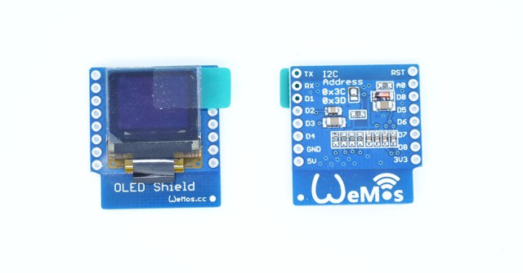

* **Screen Size:** 64×48 pixels (0.66” Across)
* **Operating Voltage:** 3.3V
* **Driver IC:** SSD1306
* **Interface:** IIC(I2C)
* **IIC Address:** 0x3C or 0x3D

The shield uses the I2C pins, so you can still connect another I2C device (if it uses a different address) and the other pins are available

|  |  |
| --- | --- |
| **D1 mini** | **Shield** |
| D1 | SCL |
| D2 | SDA |

**Code**

You will need to add the [**https://github.com/mcauser/Adafruit\_SSD1306**](https://github.com/mcauser/Adafruit_SSD1306) library

The following code example is a simple hello world type example

|  |  |
| --- | --- |
| **[Source code](http://www.esp8266learning.com/wemos-oled-shield-example.php" \l "codesyntax_3" \o "Click to show/hide code block)** | **[https://i0.wp.com/www.esp8266learning.com/wp-content/plugins/wp-synhighlight/themes/default/images/code.png?w=640](http://www.esp8266learning.com/wemos-oled-shield-example.php#codesyntax_3)** **[https://i1.wp.com/www.esp8266learning.com/wp-content/plugins/wp-synhighlight/themes/default/images/printer.png?w=640](http://www.esp8266learning.com/wemos-oled-shield-example.php#codesyntax_3)** **[https://i0.wp.com/www.esp8266learning.com/wp-content/plugins/wp-synhighlight/themes/default/images/info.gif?w=640](http://www.esp8266learning.com/wp-content/plugins/wp-synhighlight/About.html)** |

#include <SPI.h>

#include <Wire.h>

#include <Adafruit\_GFX.h>

#include <Adafruit\_SSD1306.h>

// SCL GPIO5

// SDA GPIO4

#define OLED\_RESET 0 // GPIO0

Adafruit\_SSD1306 display(OLED\_RESET);

#define NUMFLAKES 10

#define XPOS 0

#define YPOS 1

#define DELTAY 2

#define LOGO16\_GLCD\_HEIGHT 16

#define LOGO16\_GLCD\_WIDTH 16

void setup() {

Serial.begin(9600);

// by default, we'll generate the high voltage from the 3.3v line internally! (neat!)

display.begin(SSD1306\_SWITCHCAPVCC, 0x3C); // initialize with the I2C addr 0x3C (for the 64x48)

// init done

display.display();

delay(2000);

// Clear the buffer.

display.clearDisplay();

// text display tests

display.setTextSize(1);

display.setTextColor(WHITE);

display.setCursor(0,0);

display.println("Hello, world!");

display.display();

delay(2000);

display.clearDisplay();

}

void loop() {

}

**Links**  
[**OLED Shield for WeMos D1 mini 0.66″ inch 64X48 IIC I2C Compatible**](http://s.click.aliexpress.com/e/3RFYr7YRV)

4 comments to Wemos OLED shield example

Mike Morrow

28th August 2017 at 7:46 am · Reply

Here’s what I had to do to see anything on the screen. (0,0) is too high and too far left

// text display tests

display.setTextSize(1);

display.setTextColor(WHITE);

display.setCursor(32,20);

display.println(“Hello, world!”);

display.display();

..

HYKGOML

1st October 2017 at 2:32 am · Reply

// text display tests

display.setTextSize(1);

display.setTextColor(WHITE);

display.setCursor(31,8);

display.println(“123456789AB”);

display.setCursor(31,16);

display.println(“123456789AB”);

display.setCursor(31,24);

display.println(“123456789AB”);

display.display();

delay(2000);

display.clearDisplay();

..

Miguel Angel Casanova

7th October 2017 at 9:09 pm · Reply

Thanks Mike Morrow, you are right!

..

Greg Woods

12th October 2017 at 12:49 am · Reply

@Mike Morrow. It’s because the Adafruit library isn’t designed for 64\*48 displays. A forked version will likely work. It’s just finding one that is the problem. There are 326 forks… of varying quality!